**考前资料：教师资格证面试考前预测试题-高中英语**

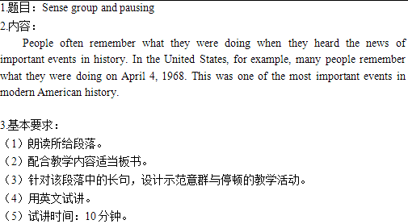

【教案】

Teaching Aims:

Knowledge aim: Students will know what sense group is and master how to pause between sense groups.

Ability aim: Students can use the method to divide a long sentence into several parts and read the sentence more fluently.

Emotional aim: Students will improve their intonation and not be afraid of speaking English.

Teaching Key Points:

Students know the concept of sense group and pausing point of a long sentence.

Teaching Difficult Points:

Students can apply the pause between sense groups into daily reading to improve their pronunciation and intonation.

Teaching Methods:

Communicative teaching method, task-based teaching method, Audio-lingual teaching method.

Teaching Aids:

PPT, Blackboard and so on

Teaching Procedures:

Step 1: Warming up

1. Greetings

2.A tongue twister: I wish to wish the wish you wish to wish, but if you wish the wish the witch wishes, I won't wish the wish you wish to wish.

Step 2: Presentation

1.Ask students how to read a sentence quickly and in rhyme.

2.Read the first sentence twice. The first time without sense group pausing and the second time with it. Let students compare the two and find out the difference. Sense group is a meaning unit.

3.Explain the principle of sense group, which is according to

(1)grammar

(2)meaning

(3)punctuation

4. Divide the first sentence mainly according to grammar.

Step 3: Practice

1. Students read the first sentence, pausing according to sense group.

2. Students try to divide sense groups of the second sentence and read it.

Step 4: Production

Role-play: Students imagine a dialogue with a foreigner and apply sense group pausing in the dialogue. teacher will give them 10 minutes to prepare it and 10 minutes later, invite some students to role the conversation in the front.

Step 5: Summary & Homework

Summary : students look at the blackboard and summarize this class.

Homework: seek for a part of an English movie to make a dubbing.

Blackboard design:

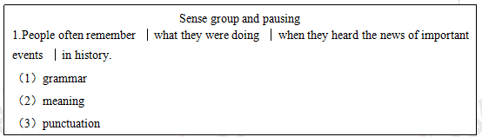

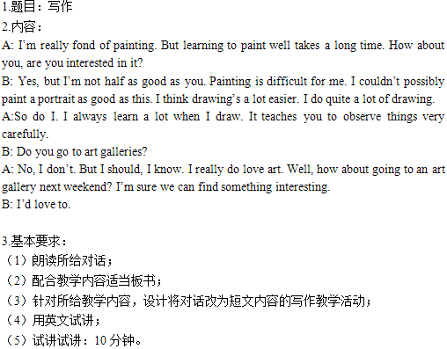

【教案】

Teaching Aims:

Knowledge aim: Students will master the content about hobbies.

Ability aim: Students can improve their writing ability about hobbies, such as drawing.

Emotional aim: Students will foster a hobby and know how to keep it.

Teaching Key Points:

Students know the content about hobbies and can improve their writing ability about hobbies.

Teaching Difficult Points:

Students can learn how to write, basing on their hobbies..

Teaching Methods:

Communicative teaching method, task-based teaching method, situational teaching method.

Teaching Aids:

PPT, Blackboard and so on

Teaching Procedures:

Step 1: Warming up

1.Greetings

2. Show two pictures about hobbies , ask all students to observe and describe.

Step 2: Pre-writing

1. Divide students into two groups, group A and group B and ask them to read the the dialogue.

2. Lead students to summary the main idea.

3.Read the dialogue by themselves again, then ask them some questions to get details.

(1) What are they fond of?

(2) How about drawing, what can it teach you?

(3) Where will they go?

4. Ask students to work in groups and discuss, do a survey on hobbies and reason, collecting key points.

Step 3: While-writing

Students write an article within 20 minutes.

Step 4: Post-writing

1.Self editing: students work in pairs to check if there are faults in spelling and grammar.

2.Sharing: choose 1-2 writing and show it on the screen.

3.Evaluating: appreciate and give comments.

Step 5: Summary & Homework

Summary : students look at the blackboard and summarize this class.

Homework:students talk about their hobbies to their friends or parents.

Blackboard design:

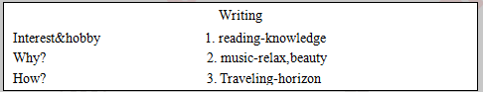

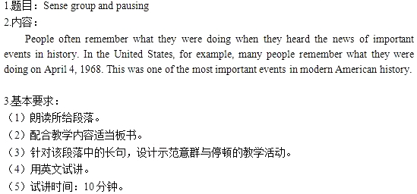【教案】

Teaching Aims:

Knowledge aim: Students will know what sense group is and master how to pause between sense groups.

Ability aim: Students can use the method to divide a long sentence into several parts and read the sentence more fluently.

Emotional aim: Students will improve their intonation and not be afraid of speaking English.

Teaching Key Points:

Students know the concept of sense group and pausing point of a long sentence.

Teaching Difficult Points:

Students can apply the pause between sense groups into daily reading to improve their pronunciation and intonation.

Teaching Methods:

Communicative teaching method, task-based teaching method, Audio-lingual teaching method.

Teaching Aids:

PPT, Blackboard and so on

Teaching Procedures:

Step 1: Warming up

1. Greetings

2.A tongue twister: I wish to wish the wish you wish to wish, but if you wish the wish the witch wishes, I won't wish the wish you wish to wish.

Step 2: Presentation

1.Ask students how to read a sentence quickly and in rhyme.

2.Read the first sentence twice. The first time without sense group pausing and the second time with it. Let students compare the two and find out the difference. Sense group is a meaning unit.

3.Explain the principle of sense group, which is according to

(1)grammar

(2)meaning

(3)punctuation

4. Divide the first sentence mainly according to grammar.

Step 3: Practice

1. Students read the first sentence, pausing according to sense group.

2. Students try to divide sense groups of the second sentence and read it.

Step 4: Production

Role-play: Students imagine a dialogue with a foreigner and apply sense group pausing in the dialogue. teacher will give them 10 minutes to prepare it and 10 minutes later, invite some students to role the conversation in the front.

Step 5: Summary & Homework

Summary : students look at the blackboard and summarize this class.

Homework: seek for a part of an English movie to make a dubbing.

Blackboard design:

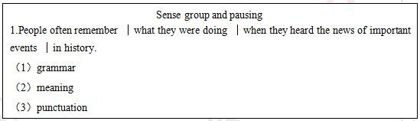

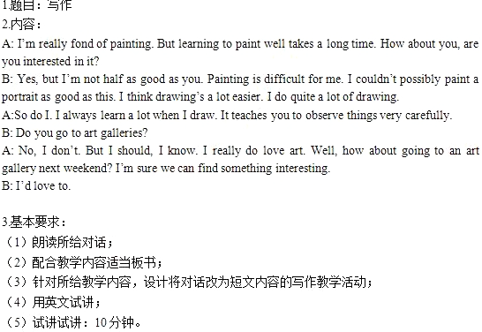

【教案】

Teaching Aims:

Knowledge aim: Students will master the content about hobbies.

Ability aim: Students can improve their writing ability about hobbies, such as drawing.

Emotional aim: Students will foster a hobby and know how to keep it.

Teaching Key Points:

Students know the content about hobbies and can improve their writing ability about hobbies.

Teaching Difficult Points:

Students can learn how to write, basing on their hobbies..

Teaching Methods:

Communicative teaching method, task-based teaching method, situational teaching method.

Teaching Aids:

PPT, Blackboard and so on

Teaching Procedures:

Step 1: Warming up

1.Greetings

2. Show two pictures about hobbies , ask all students to observe and describe.

Step 2: Pre-writing

1. Divide students into two groups, group A and group B and ask them to read the the dialogue.

2. Lead students to summary the main idea.

3.Read the dialogue by themselves again, then ask them some questions to get details.

(1) What are they fond of?

(2) How about drawing, what can it teach you?

(3) Where will they go?

4. Ask students to work in groups and discuss, do a survey on hobbies and reason, collecting key points.

Step 3: While-writing

Students write an article within 20 minutes.

Step 4: Post-writing

1.Self editing: students work in pairs to check if there are faults in spelling and grammar.

2.Sharing: choose 1-2 writing and show it on the screen.

3.Evaluating: appreciate and give comments.

Step 5: Summary & Homework

Summary : students look at the blackboard and summarize this class.

Homework:students talk about their hobbies to their friends or parents.

Blackboard design:

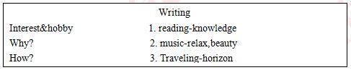

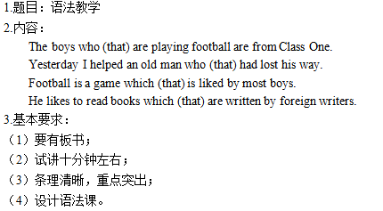

【教案】

Teaching Aims

Knowledge aims

Students will know the form and usage of attributive clause lead by who, which and that.

Ability aim

Students can enhance their ability of understanding the knowledge which is more professional and difficult.

Emotional aim

After this lesson, students will improve their confidence of learning English.

Teaching Key &Difficult Points

Key point: attributive clause;

Difficult point: How to understand and use the attributive clause.

Teaching procedures

Step 1: Warming up

Show some adverbial clause on the screen, let students look at this sentences carefully and find the similarities among them. After observation, do a conclusion together :“They all describe the verbs like adverbs.”

I will call you as soon as I arrive in Beijing.

Where you work, you should work hard.

My friends like me because I’m honesty.

Step 2: Presentation

Show these four sentences on the blackboard.

1.Students try to translate these sentences. Invite some students to share their answers. The answers are as follows:

正在踢足球的男孩是一班的。

昨天我帮助了一位迷路的老人。

足球是大多数男孩所喜欢的运动。

他喜欢外国作家写的书。

2. Let them observe these two sentence, find the common between them. Tell them the function and meaning of attributive clause.

The rules are shown in the following part:

① The function of attributive clause is to modify the previous word (antecedent).

② When the antecedent is human being, we should use the relative pronoun: who.

③ When the antecedent is something, we should use the relative pronoun: which.

④ No matter the the antecedent is something or someone, the relative pronoun: that can be used.

Step 3: Practice

1.Give them several minutes to make their own sentences using attributive clause.

2.Read the some sentences and try to translate them.

Step 4: Production

Divide them into group of four and in five minutes to discuss the impressive person who has made great influence on you. Try to use the attributive clause.

Step 5: Summary & Homework

1.Ask students to summarize the usage and function of attributive clause.

2.After class, please search more information about attributive clause.

**Blackboard design**

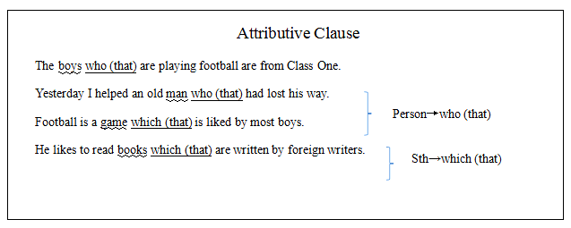



【教案】

Teaching aims:

Knowledge aim: Students can master the usage of formal subject.

Ability aim: Students can use formal subject to communicate in their daily life.

Emotional aim: Students can enhance their interest in learning English.

Key and difficult point: Students can use formal subject to communicate in their daily life.

Teaching procedure:

Step 1: Warming-up

The teacher plays a documentary video about the earthquake in Wenchuan. Then asks students to talk about their feelings after watching. And lead in the topic.

Step 2: Presentation

The teacher lets students to read the passage and get the main idea. Then the teacher picks the last sentence out. The teacher will use the sentence as example to explain the structure and usage of formal subject.

Step 3: Practice

After explaining, the teacher will show some normal sentences. Students should transfer them into formal subject structure.

For example: Taking good care of the orphans is very important.

→It is very important to take good care of the orphans.

Step4: Production

The teacher lets students talk with their deskmates. They should come up with some ways to help the orphans. Then invites some students to show their opinions.

Step5: Summary and Homework

The teacher summarizes what they have learnt today. Then after class, students could say something to these orphans and take a video. The teacher will help them sent it to the orphan.

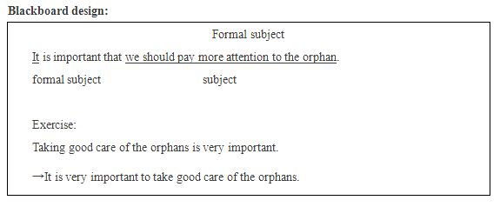

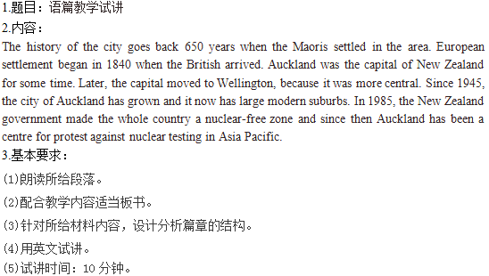

【教案】

Teaching aims:

Knowledge aim: students will know more about the history of New Zealand.

Ability aim: students can catch some detailed information about the passage.

Emotional aim: students will appreciate different culture and history.

Key and difficult point:

Students will get the history about New Zealand.

Students can express their ideas about the topic.

Teaching procedure:

Step 1: Warming-up

Greet the students.

Watch a clip about “Dad, where are we going” and try to describe the video.

Step 2: Pre-reading

Show some pictures to introduce New Zealand’s background information.

Step 3: While-reading

1st reading: leave the question to you--try to find the key time-points?

2nd reading: now try to find the issues according to responding time-points?

3rd reading: leave the question to them-what is the capital before and now?

Step4: Post-reading

Activity 1: invite two students to retell the passage according the timeline on the blackboard.

Activity 2: divide them into groups of 3 to talk about which country do they like best?

Step5: Summary and homework

Invite a student to make a summary then leave them the homework-search online for the development of coffee culture in China.

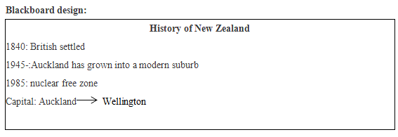

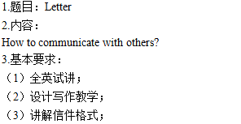

【教案】

Teaching Aims:

Knowledge aim: By the end of the class, students will know some expressions of advice and the format of a letter, which includes: an appellation, a body part, a complimentary close and a signature.

Ability aim: Students’ writing ability of letter can be improved by the end of the class.

Emotional aim: Students will be aware of the importance of writing English letter.

Students' interest of learning English can be inspired.

Teaching Key Points:

Students know the format of an English letter and how to make a suggestion.

Teaching Difficult Points:

Students can apply expressions of advice and the format of English letter into their own life.

Teaching Methods:

Communicative teaching method, task-based teaching method, situational teaching method.

Teaching Aids:

PPT, Blackboard and so on

Teaching Procedures:

Step 1: Warming up

1.Greetings

2.Sing an English song We don’t talk anymore, invite the whole students to clap when singing together and lead to the topic.

Step 2: Pre-writing

1.Free talk: Let students talk about the importance of communication in our daily life in group of four, 3 minutes later invite some groups to show their ideas.

2.Set up situation: Let's say our friend Li Ming is very upset recently, because he has a problem in the aspect of communicating with others, we should write a letter to give him some advice.

3.Format: Guide and teach students the format of English letters, which includes: an appellation, a body part, a complimentary close and a signature.

4.Content: Teach students the key sentence structures about how to make a suggestion.(eg: I suggest that you...)

5.Brainstorming: Let students share their ideas about how to communicate with others with their partners, and decide which are the best ideas, make a list of those ideas, then put those ideas into a map so that students can easily see them when they write.

Step 3: While-wirting

Give students some guidance, such as: pay attention to the punctuation, sentence structure, tenses and format. 15 minutes would be given to them to complete their letter within 100 words individually.

Step 4: Post-writing

1.Self-editing: Ask students to check their letter according to the format and sentence structures on the blackboard.

2.Peer editing: Ask students to check and edit their partners’ letter and give them some suggestions.

3.Share: Invite some students to share their letter in front of the class and teacher gives them some comments.

Step 5: Summary & Homework

Summary : Invite a little teacher sum up what we have learned today.

Homework: Let students search more information about how to communicate with others.

